**Weather Data Analysis – Temperature Trend**

**Prediction**

Introduction

Climate change analysis requires understanding temperature trends. This project forecasts future temperatures using time-series models (Prophet).

Objective

To understand global and regional temperature trends over the last decade and predict future temperatures using time-series models.

🔍 Key Findings

1. Historical Temperature Trends

* Cities like Montreal and New York show clear seasonal cycles, with cold winters and warm summers.
* Cities like Tel Aviv remain relatively stable with mild seasonal variation and consistently higher temperatures.

2. Rolling Averages & Anomalies

* 30-day rolling averages revealed long-term seasonal patterns.
* Anomalies (deviations from rolling means) helped detect heatwaves and cold spells, with more extreme fluctuations in colder climates like Montreal.

3. Forecasting with Prophet

* The model successfully captured the annual seasonality in temperature data.
* Forecast for New York showed predictable patterns with increasing uncertainty in longer horizons.
* The model’s yearly seasonality component clearly showed typical high and low months.

📈 Model Strengths

* Prophet handled missing data and strong seasonal effects well.
* Generated interpretable forecasts with uncertainty bounds.
* Suitable for climate-related planning (e.g., energy usage, agriculture, public health).

Visualization

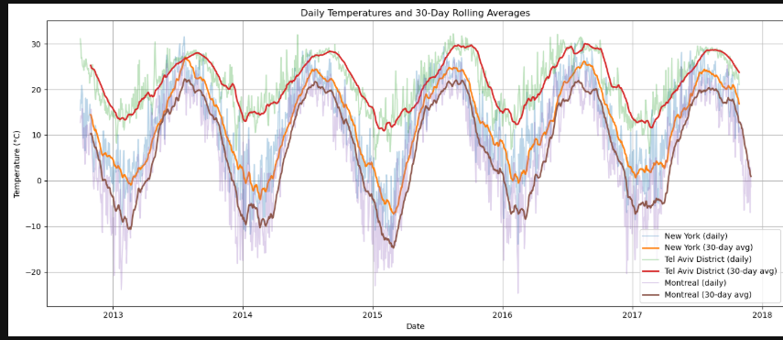

The temperature trend visualization for New York, Tel Aviv District, and Montreal:

Key Insights:

Tel Aviv shows consistently high temperatures year-round (mid-20s to 30s °C).

Montreal and New York both display strong seasonality, with cold winters and warm summers.

The 30-day rolling average smooths out short-term fluctuations, making long-term patterns clearer.

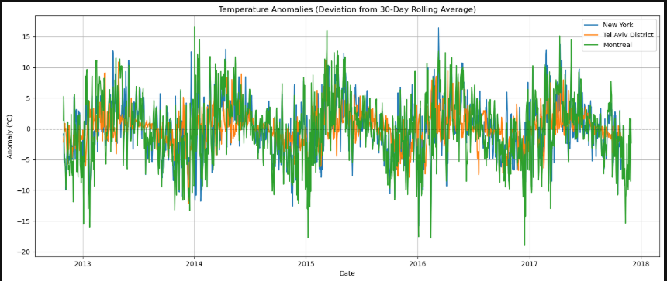

✅ This plot shows temperature anomalies — the deviation of daily temperatures from their 30-day rolling averages:

Insights:

Positive spikes (above the 0 line): Likely heatwaves or unusually warm days.

Negative dips (below the 0 line): Cold spells or unexpectedly cool days.

Montreal and New York exhibit more extreme seasonal variation, while Tel Aviv remains relatively stable with fewer large anomalies.

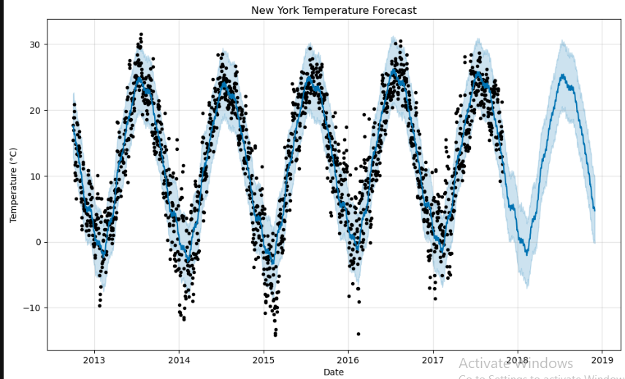

✅ Forecast Analysis: New York Temperature Strong seasonality: The model clearly captures the yearly temperature cycles — warm summers and cold winters — with repeating peaks and valleys.

Good fit to historical data: The black dots (actual data) align closely with the blue forecast line, showing Prophet modeled the historical trend effectively.

Future prediction (2018–2019): The shaded blue area represents the forecast uncertainty interval. It widens further out, which is expected in long-range forecasting.

Some missing data (2016 dip) is visible but handled reasonably well by the model.

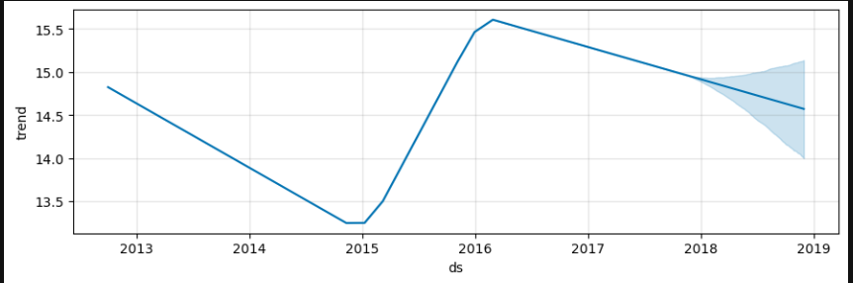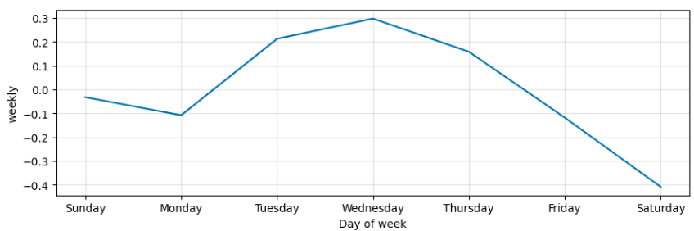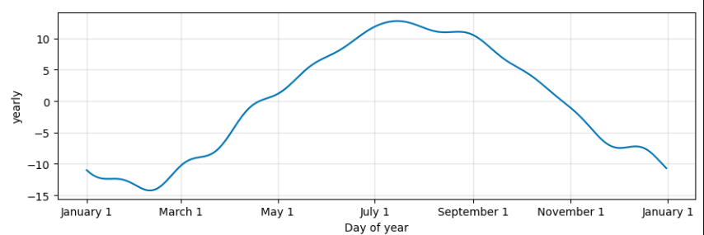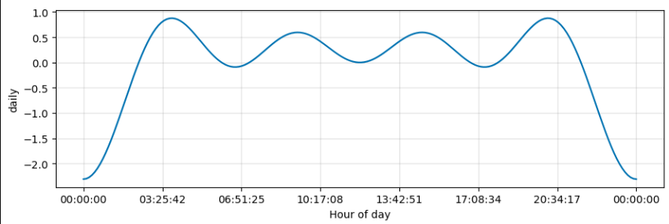

✅ Conclusion

Temperature patterns are strongly seasonal and location-dependent. Time-series models like Prophet can effectively forecast future temperatures and detect anomalies, aiding climate-related decision-making.